# Description

On the Rates page, the percentage value in the **Assumptions** text is often mismatched with the **Estimated down payment** percent.

# Reproduce

Login to Better.com as a standard user

Navigate to the Rates page

Click the “Assumptions: Purchasing a $<price>k home in Westbury, NY with <percent>% down...” button

Set the **Purchase price** to $300,000 and the **Estimated down payment** to $5,000

Click Update

The percentage in the Assumptions text does not match the percentage in the Estimated down payment field

* The Assumptions text reads: “Assumptions: Purchasing a $300k home in Westbury, NY with 1.67% down...”
* The Estimated down payment has a percentage of 1.7%

# Screenshots

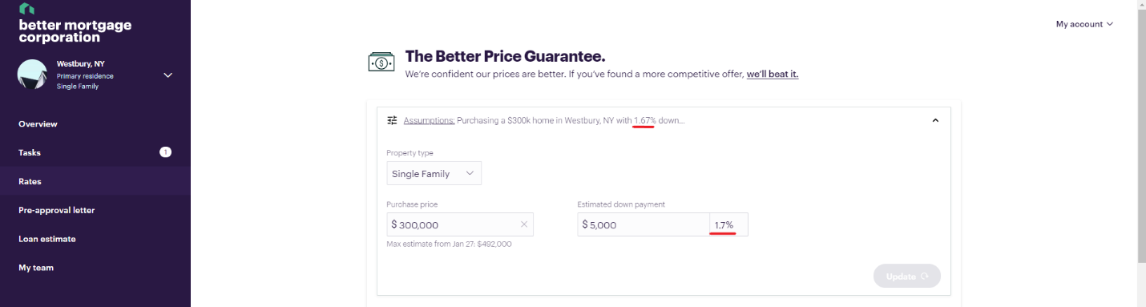

Figure 1 – The **Assumptions** percent value does not match the **Estimated down payment** percent value after altering the **Purchase price** to $300,000 and the **Estimated down payment** to $5,000.